PRÁCA S ATLASOM
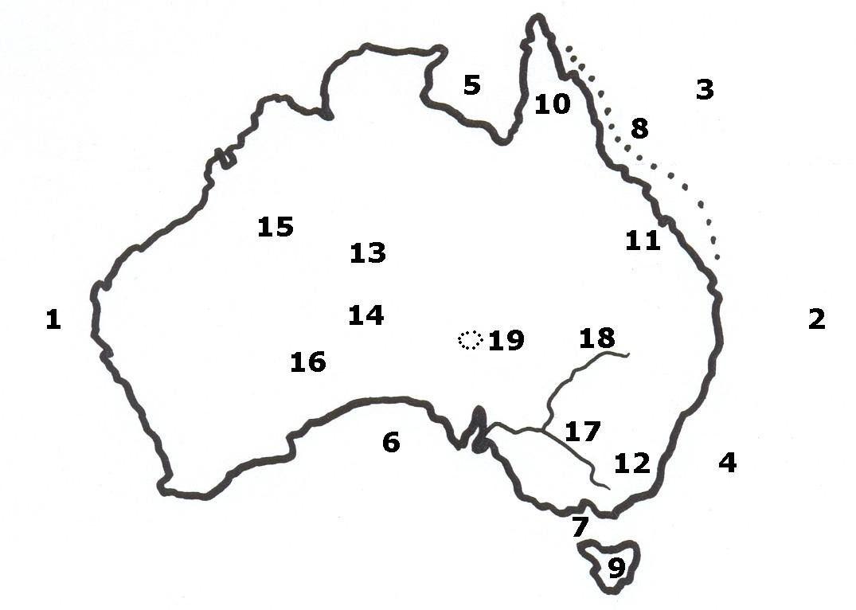

1. ................................................... oceán 10. ................................................... polostrov
2. ................................................... oceán 11. ................................................... vrchy
3. ................................................... more 12. ................................................... alpy
4. ................................................... more 13. ................................................... vrchy
5. ................................................... záliv 14. ................................................... vrchy
6. ................................................... záliv 15. ................................................... púšť
7. ................................................... prieliv 16. ................................................... púšť
8. ................................................... bariéra 17. ................................................... rieka
9. ................................................... 18. ................................................... rieka
19. ................................................... jazero

